“Київський фаховий коледж зв’язку”

Циклова комісія Комп’ютерної та програмної інженерії

**ЗВІТ ПО ВИКОНАННЮ**

**ЛАБОРАТОРНОЇ РОБОТИ №2**

з дисципліни: «Операційні системи»

**Тема:** **“Знайомство з інтерфейсом та можливостями ОС Linux”**

Виконали студенти

групи КСМ-13а

Команда “Viper”:

Малієнко А. М.,

Мішин А. О.

та Нерощин Д.О.

Перевірив викладач

Сушанова В.С.

Київ 2022

**Мета роботи:**

1. Отримання практичних навиків роботи з середовищами віртуальних машин та операційними системами різних типів та сімейств – їх графічною оболонкою, входом і виходом з системи, ознайомлення зі структурою робочого столу, вивчення основних дій та налаштувань при роботі в системі.

**Матеріальне забезпечення занять**

1. ЕОМ типу IBM PC.

2. ОС сімейства Windows (Windows 7).

3. Віртуальна машина – Virtual Box (Oracle).

4. Операційна система GNU/Linux – CentOS.

**Завдання для попередньої підготовки.**

**1. Прочитайте короткі теоретичні відомості до лабораторної роботи та зробіть невеликий словник базових англійських термінів з питань призначення команд та їх параметрів.**

|  |  |
| --- | --- |
|  |  |
|  |  |
|  |  |
|  |  |

**2. Вивчіть матеріали онлайн-курсу академії Cisco “NDG Linux Essentials”:**

**- Chapter 3 - Working in Linux**

**- Chapter 4 - Open Source Software and Licensing**

**3. Пройдіть тестування у курсі NDG Linux Essentials за такими темами:**

**- Chapter 03 Exam**

**- Chapter 04 Exam**

**4. Дайте визначення наступним поняттям:**

**- CLI-режим**

**- Термінал на основі графічного інтерфейсу користувача**

**- Віртуальний термінал**

**5. Підготувати в електронному вигляді початковий варіант звіту:**

**- Титульний аркуш, тема та мета роботи**

**- Словник термінів**

**- Відповіді на п.5 та п.6 з завдань для попередньої підготовки**

**Хід роботи.**

**1. Робота в графічному режимі в ОС сімейства Linux (робота з інтернет-джерелами):**

**1.1. Оберіть графічну оболонку для ОС сімейства Linux, яку ви хочете розглянути. Розгляньте**

**структуру робочого простору користувача, та опишіть основні його компоненти (***показано**

**основні компоненти оболонки Ubuntu Linux ):**

**- Закладка Applications**

**- Закладка Places**

**- Меню System**

**- Навігаційний простір Activities overview**

**Ubuntu Linux includes various components that help you navigate, run programs, and manage your system. The main components include:**

**The Applications tab:**

**This tab is used to access installed programs and applications. It contains categories of programs that help the user find the desired application. The user can search for applications by name or category. You can also view the most recently used applications here.**

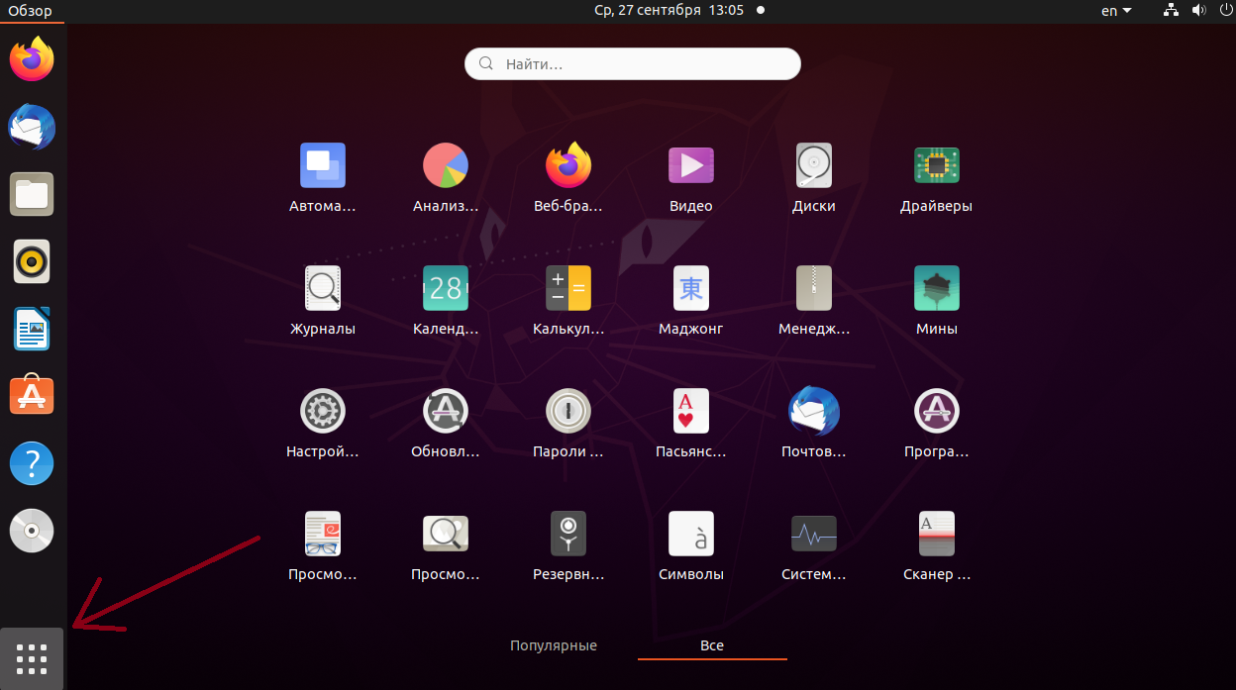

**The Places tab:**

**Places provides access to various locations on your computer and network. This includes files and folders stored on your device, as well as network shares. You can quickly access your documents, downloaded files, desktop, and other important places on your system.**

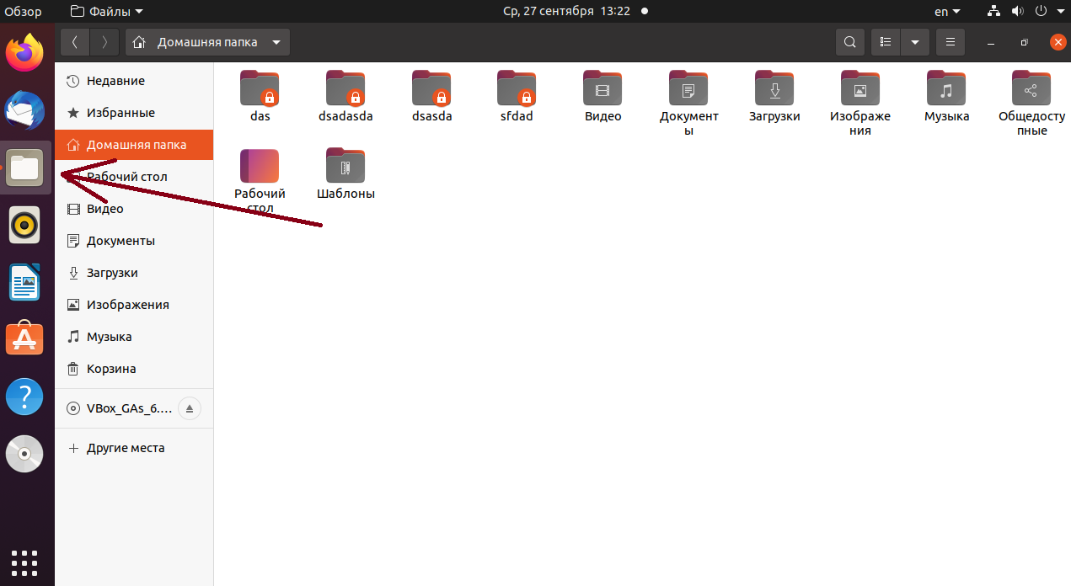

**System menu:**

**The System menu contains various system tools and options. You can configure the system, manage user accounts, network settings, and other administrative tasks from this menu.**

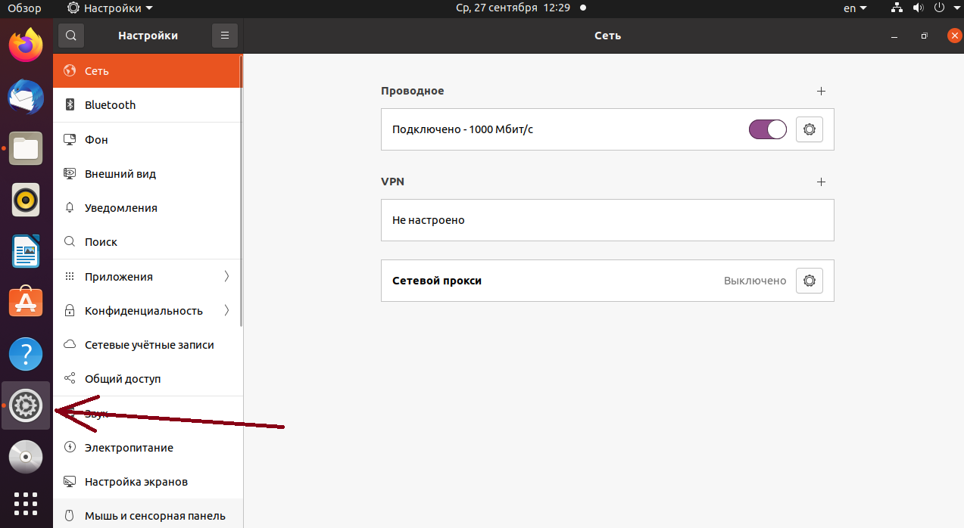

**The Activities overview navigation space:**

**Activities overview is a special mode that can be activated by pressing the "Super" key (usually the key with the Ubuntu or Windows logo) or by using the mouse in the upper left corner of the screen. It includes a detailed view of all running programs, open windows, and desktops.**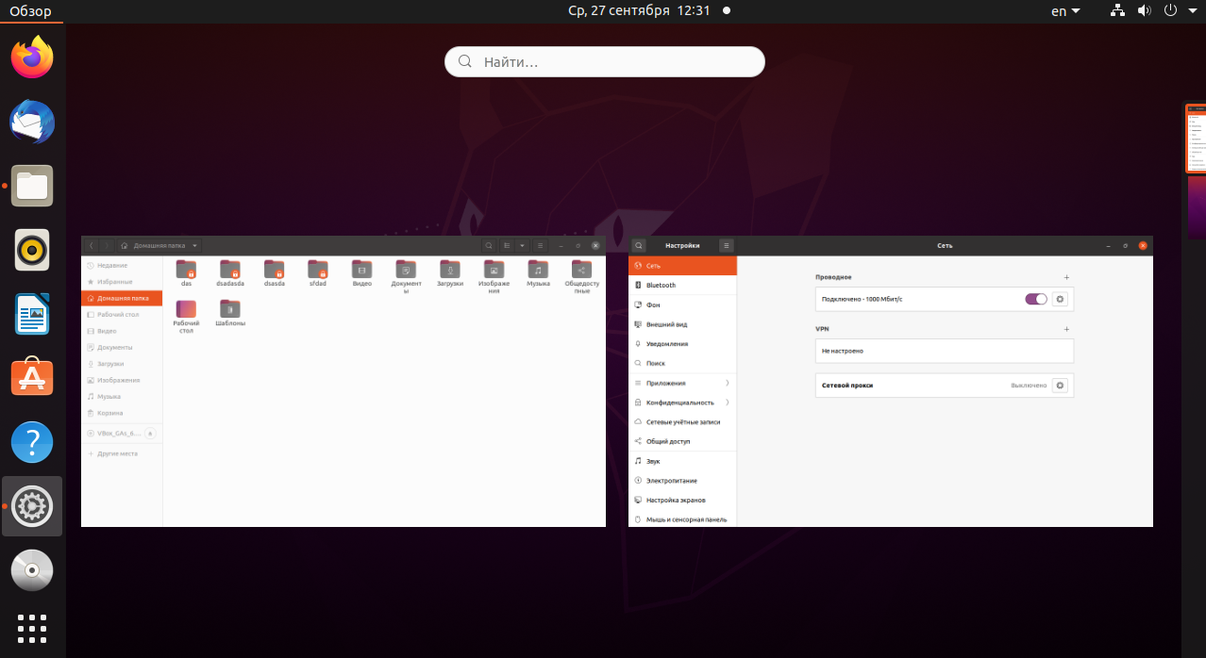

**1.2. Запуск програм. Дослідіть можливості запуску додатків різними способами (описати спосіб і по-**

**можливості показати скріншоти):**

**- Запуск програм через панель швидкого запуску**

**- Запуск програм через пошук в меню**

**- Запуск програм через віджет запуску**

**- Запуск програм через глобальне меню**

**Launch programs through the Quick Launcher:**

**There is usually a Quick Launcher on the top or bottom panel (depending on your configuration). It may have icons for the most important programs.**

**To launch a program, simply click on the corresponding program icon on the panel.**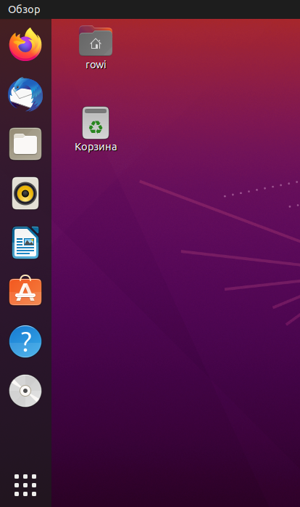

**Launch programs by searching the menu:**

**Click on "Show Applications" in the lower-left corner of the screen or the "Super" key (usually with the Ubuntu logo) on your keyboard to open the application menu.**

**You can start typing the name of the program in the search box or simply scroll through the list of programs to find the one you want.**

**When you find the program you want, click on its icon to launch it.**

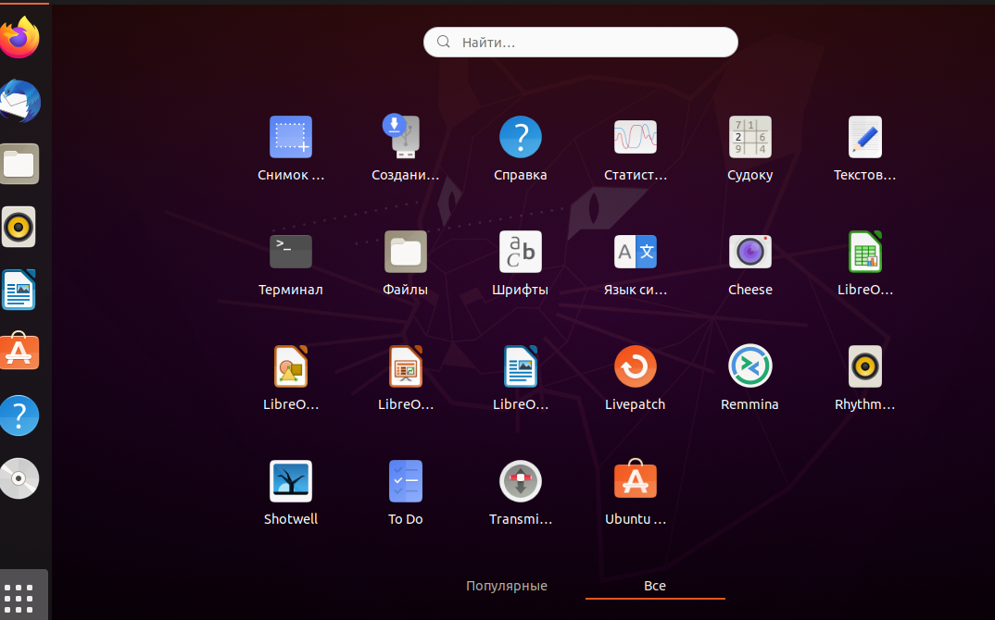

**Launch programs through a launcher widget:**

**On some desktops, such as GNOME, you can add a launcher widget to your desktop or panel.**

**To add a widget, right-click on the desktop or panel, select "Add to Panel" or "Add to Desktop", and select the program you want to add.**

**After adding a widget, you can click on it to launch the program.**

**Launch programs through the global menu:**

**Some desktops, such as Unity, have a global menu that is located in the top bar.**

**Click on the name of the current application in the top bar and you will see the global menu with a list of available options for that application.З цього меню ви можете launch a new program if it is available on your system.**

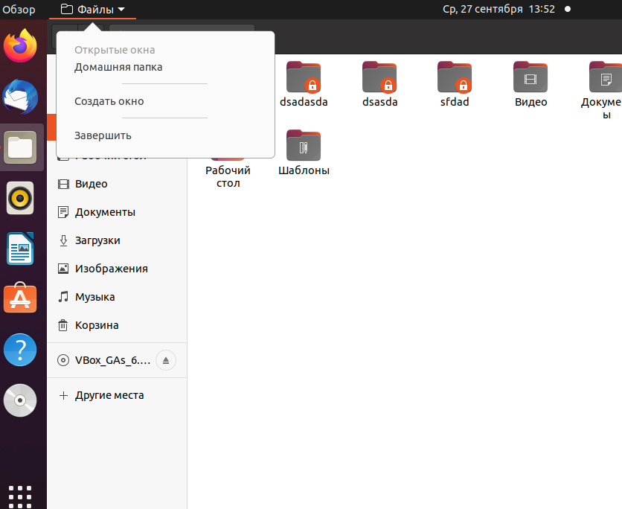

**1.3. Вихід з системи та завершення роботи в Linux. Як виконати в графічному інтерфейсі наступні дії**

**(наведіть скріни):**

**- Зміна користувача на root**

**- Перезавантаження системи**

**- Вимкнення системи**

**Зміна користувача на root:**

**Changing to root in graphical mode is not a standard or recommended security measure. In most cases, it's better to use the command line to perform tasks that require root privileges. But if you still need to change the user to root:**

**Press the "Super" key (usually the key with the Ubuntu or Windows logo).**

**Enter "root" in the search field and select "Root Terminal" or "Switch User to Root" (depending on your version of Ubuntu).**

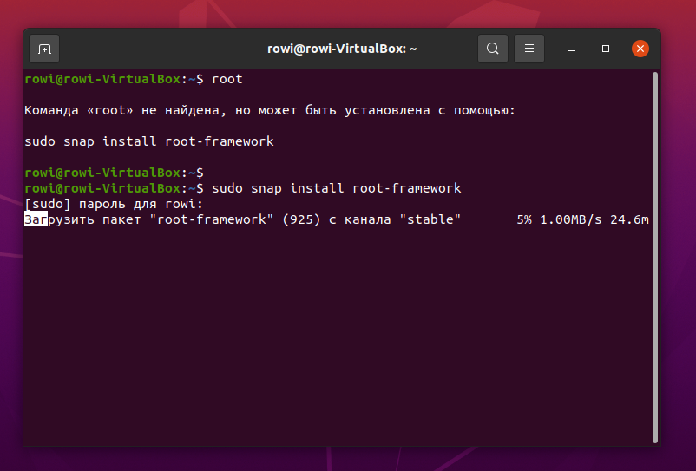

**Restart the system:**

**Press the Super key to open the Activities Overview.**

**Type "reboot" or "reboot" in the search box.**

**You will see the option "Restart" or "Reboot". Click it and the system will reboot.**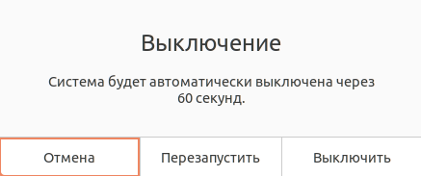

**Shut down the system:**

**You need to do the same as in the previous step, but select the Shutdown option**

**Готував студент ,,,,**

**2. Робота в середовищі мобільної ОС.**

**2.1. Опишіть головне меню вашої мобільної ОС, який графічний інтерфейс вона використовує?**

**2.2. Опишіть меню налаштувань компонентів мобільного телефону.**

**2.3. Використання комбінацій клавіш для виконання спеціальних дій.**

**2.4. Вхід у систему та завершення роботи пристрою. Особливості налаштувань живлення батареї.**

***Готувала студентка Малієнко А.М.***

**Control questions:**

**1. Provide examples of Linux server applications for a database server, a mail server, and a**

**file sharing servers.**

**1.Database server:**

MySQL is a free relational database management system that was developed by TcX to improve the performance of processing large databases. This open source database management system (DBMS) was created as an alternative to commercial systems. MySQL was initially very similar to mSQL, but over time it has been expanded and now MySQL is one of the most common database management systems. It is used primarily for creating dynamic web pages, as it has excellent support from a variety of programming languages.

PostgreSQL is an open-source object-relational database management system, ORDBMS, that is not owned or controlled by a single company or individual. Because postgresSQL software is open source, it is managed primarily through coordinated online efforts by an active worldwide community of developers, enthusiasts, and other volunteers.

**2. Message distribution servers:**

**Postfix is a free mail transfer agent (MTA).**

Postfix was created as an alternative to Sendmail. It is believed that Postfix is faster, easier to administer, more secure and, most importantly, compatible with Sendmail.

The Postfix architecture is made in the UNIX style, where simple programs perform a minimal set of functions, but perform them quickly and reliably. When the mail system is idle, unnecessary daemons can stop working, thereby freeing up memory, and if necessary, they can be restarted by the master daemon.

**3. File sharing services:**

OwnCloud is an open source cloud resource for sharing, storing and synchronizing data. It allows you to store all your files on your own server without the participation of third-party services. In this article, we will help you install and configure ownCloud through the cPanel control panel.

Nextcloud is a software that helps organize work at enterprises. In particular, it helps to organize and exchange corporate documents (ECM/DMS). The system is distinguished by its open source code, which can be modified in any way. In addition, it gives you the freedom to choose the installation location - in the cloud or on your own servers.

**2. Compare the Bourne, C, Bourne Again (Bash), the tcsh, Korn shell (Ksh), and zsh shells.**

**Bash and zsh.**

Your operating system chooses a standard shell for you, and that choice is almost always bash. Sit down in front of a Linux distribution - or even a Mac - and you will almost always have a bash shell environment. Bash has quite a few advanced features, but you probably won't use them unless you're programming shell scripts.

On embedded Linux systems or BSD systems, you will have an ash shell. But ash is a Bourne-based shell and is largely compatible with bash. Any knowledge you have gained from using bash carries over to using the ash or dash shell, although some advanced scripting features are not available in this lightweight shell.

Almost every shell you'll encounter is based on Bourne and works in the same way as zsh.

That's why zsh is popular. This new shell is compatible with bash, but contains more features. The zsh shell offers built-in spelling correction, improved command line completion, downloadable modules that act as plugins for your shell, global aliases that allow you to use file aliases or anything else on the command line instead of just commands, and more shell support. It's like bash, but with a lot of extra features, extra functions, and customizable options that you can appreciate if you spend a lot of time on the command line.

##### If you're familiar with bash, you can switch to zsh without learning a different syntax - you'll just get additional features. if you're familiar with zsh, you can switch to bash without learning a different syntax - you just won't have access to those features.

##### *C shell*

C shell, executable: csh Command shell developed by vi author Bill Joy. The csh scripting language was based, as the name implies, on the C language. Because at that time, in 1978, it was the most popular programming language among BSD UNIX developers and users. At the moment, a free implementation of csh, tcsh, is more popular.

TENEX C Shell, executable: tcsh. It was in tcsh that autocomplete was once first introduced. It is the default shell in FreeBSD. You can read more about it here.

To illustrate the difference in syntax, here are some example scripts that do the same thing for csh and a sh-compatible shell.

**Conditional construction:**

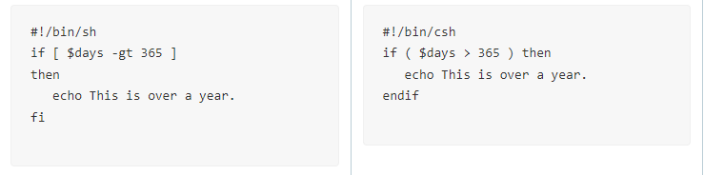**3. What is a package manager for? What package managers do you know in Linux?**

## A package manager is a set of software in Linux that installs, configures, uninstalls, and updates individual packages (programs) or the entire system.

## Some of the best known package managers are:

## Yum and RPM - in Red Hat similar systems;

## Dpkg - on Debian-like systems;

## Pacman on Arch Linux;

## Portage and Paludis in Gentoo

### Debian-based package managers

### Ubuntu and Debian are considered one of the most widely used desktop Linux operating systems on the market today. Their package managers are separated, with the lowest-level package management system being "dpkg", for "Debian Package". It is a barebones package management software, with tools for installing, uninstalling, and creating packages.

### APT package manager

### This is where interfaces like apt and aptitude come into play. APT, short for Advanced Package Tool, is much more advanced in functionality than dpkg. It can also install, remove, and create packages, but its functionality goes much further. APT can automatically update packages, install dependencies, and automatically download your packages from the Internet. It is one of the most common package managers installed on modern distributions, with Ubuntu, Debian, and most other Debian-based operating systems installed.

**RPM package manager**

RedHat and CentOS are among the most widely used server operating systems found on servers today. The main package management software installed on these systems is RPM, which is short for Red Hat Package Manager. This package manager also performs basic operations such as installing and uninstalling packages and, like dpkg, also cannot manage or install packages directly from the Internet.

***4. What security tools are used in Linux?***

**Security tools for Linux:**

**1. MISP**

MISP, commonly known as the "Malware Information Sharing Platform", is a threat intelligence platform for sharing, storing and correlating threat intelligence signs, economic racketeering information, susceptibility information and anti-violence information. This Linux security tool is useful for storing, sharing, collaborating on cybersecurity signs, researching malware, and using information and IoC to detect and prevent threats.

**Important features**

- Flexible enough to express complex objects and combine them together to discover information about threats, events, or related elements.

- An "intuitive user interface" allows end users to create, update, and collaborate on indicators/attributes and events.

**2. Privacy badger**

Basically, it is a privacy protection for browsers that provides security from trackers of a website visitor. Trackers usually collect information about your browser. The information collected is often shared with third parties. It is often used to create a fake profile of a particular browser. In this case, this Linux security tool prevents the data collection.

Important features

- Works as an extension for Opera, Firefox, and Chrome.

- Scans requested web pages and deactivates them by replacing the content or simply blocking requests.

- Disables WebRTC, which reveals internal IP addresses.

- This will help you browse the web more securely.

**3. Air crackle**

This is an outstanding networking application packet, consisting of a packet sniffer, detector, WPA/WPA2-PSK and WEP cracker and a utility for analyzing "802.11" wireless LANs. The software functions perfectly with any "wireless network interface controller" whose driver can transmit 802.11g and 802.11a, 802.11b traffic and supports raw surveillance mode.

**5. Why has virtualization become so relevant now?**

Today, when people talk about virtualization technologies, they usually mean server virtualization, as the latter is becoming the most popular solution in the IT market. Server virtualization means running several virtual servers on one physical server. Virtual machines or servers are programs running on a host operating system that emulate physical server devices. Each virtual machine can have an operating system installed on it, on which applications and services can be installed. Typical representatives are VmWare (ESX, Server, Workstation) and Microsoft (Hyper-V, Virtual Server, Virtual PC) products.

**6. How do you understand the concept of containerization?**

Containerization is a software deployment process that integrates the application code with all the files and libraries needed to run on any infrastructure. Typically, to run any application on a computer, you needed to install a version that matched the PC's operating system. For example, you needed to install the Windows version of a software package on a Windows PC. However, with containerization, you can create a single software package or container that will run on all types of devices and operating systems

**7. What are the advantages/disadvantages of using open source software?**

1. Advantages of open source software
2. Cheaper compared to commercial products ...
3. High reliability ...
4. Flexibility ...
5. Vulnerability to malicious attacks ...
6. Unlike commercial software, OSS may not be user-friendly ...
7. Lack of extensive customer support

There are many disadvantages to using open source software:

Lack of guarantees and support: Most freely distributed software does not have the official technical support or warranties that commercial products provide. It can be difficult for users to find help in case of problems.

Limited functionality: Some open source programs may be less functional or lack as many features as their commercial counterparts.

Compatibility with standards: Some open source projects may use proprietary standards, which can be important when integrating with other software.

Difficulty of installation and customization: For non-experienced users, installing and configuring some open source programs can be a challenge.

Lack of support updates: Some projects may stop development or support, leaving users with outdated software and potential security issues.

Low popularity: Some less popular projects may have a smaller developer community and less active support.

Licensing: Using open source may require compliance with certain licensing restrictions, requiring you to publish your own source code or restrict use in other projects.Lack of guarantees and support: Most freely distributed software does not come with the official technical support or warranties that commercial products provide. It can be difficult for users to find help in case of problems.

Limited functionality: Some open source programs may be less functional or lack as many features as their commercial counterparts.

Compatibility with standards: Some open source projects may use proprietary standards, which can be important when integrating with other software.

Difficulty of installation and customization: For non-experienced users, installing and configuring some open source programs can be a challenge.

Lack of support updates: Some projects may stop development or support, leaving users with outdated software and potential security issues.

Low popularity: Some less popular projects may have a smaller developer community and less active support.

Licensing: Using open source may require compliance with certain licensing restrictions, requiring you to publish your own source code or restrict its use in other projects.

**8. How many active virtual consoles (terminals) can be in the process of Linux operation by default. How to call them and switch between them? What are some examples?**

Linux can have several active virtual consoles (terminals) by default. These are usually virtual terminals 1 through 6, and they are available for you to log in and work. To call them and switch them, use the hotkeys:

Ctrl + Alt + F1 - Switch to the first virtual terminal (tty1).

Ctrl + Alt + F2 - Switch to the second virtual terminal (tty2).

Ctrl + Alt + F3 - Switch to the third virtual terminal (tty3).

Ctrl + Alt + F4 - Switch to the fourth virtual terminal (tty4).

Ctrl + Alt + F5 - Switches to the fifth virtual terminal (tty5).

Ctrl + Alt + F6 - Switch to the sixth virtual terminal (tty6).

So, you can use these hotkeys to switch between virtual terminals in Linux. For example, if you are in graphical mode (tty7) and want to enter text commands on the first virtual terminal (tty1), press Ctrl + Alt + F1. To return to graphical mode, press Ctrl + Alt + F7 or the corresponding tty number where graphical mode is usually located.

**9. What virtual console (terminal) serves as a graphical shell?**

In the graphical shell, the Terminal program, which is launched by the key combination "Ctrl+Alt+T" or a shortcut from the general program menu, is an important element of the operating system that allows you to run programs, create folders, copy and delete files, install applications, etc. The system utility to which you pass these commands is called the Shell or command shell. By default, Ubuntu uses a command shell called Bash. When you enter a command prompt, a window opens that shows: qwe - the name of the user account, vb - the name of the computer, the symbol ":" - a separator, "~" - the directory where the command is executed (home directory).



The shell has its own settings and provides access to system resources, and the user has his own settings when working with the system and his applications. The environment is used for this purpose.

**10. Is it possible to register in a Linux system several times under the same system name? What advantages can this provide?**

It is possible to log in to a Linux system several times under the same system name.

The main advantage of this approach is user-friendliness and increased productivity in certain scenarios. Here are some of the benefits of this functionality:

Parallel work: A user can have multiple active sessions at the same time, and this allows you to perform different tasks in parallel. For example, you can complete a task in one session and check email or work with a text editor in another.

***Висновки робив Нерощин Данііл***

**Conclusions**

In the course of the laboratory work, the Linux OS was studied, and the issue of the interface and capabilities of the Linux OS was theoretically studied in more detail.

The acquired skills of working with commands and settings will be very useful in further work with Linux. We have mastered the basics of entering commands, launching programs, as well as important settings that allow you to adapt the system to your own needs.